Experiment 8

Student Name: Nikhil Kumar UID: 25MCI10036
Branch: MCA (AI/ML) Section/Group: 25MAM-1(A)
Semester: 2-SEM Date of Performance: 31/03/2026
Subject Name: Technical Training - 1 Subject Code: 25CAP-652

- Aim of the Session:

To apply the concept of Stored Procedures in database operations in order to perform tasks like insertion, updating, deletion, and retrieval of data efficiently, securely, and in a reusable manner within the database system.

- Software Requirements:
- PostgreSQL
- pgAdmin
- Windows Operating System

- Objectives of the Session:

Apply stored procedure concepts for database operations.

- Theory:

A Stored Procedure is a precompiled collection of SQL statements stored in the database that can be executed as a single unit. It helps in improving performance, security, and code reusability.

Features of Stored Procedures:
- Reusability
- Better Performance
- Improved Security
- Reduced Network Traffic
- Modular Programming

- Practical / Experiment Steps:

Step 0: Creating sample tables and inserting records

Code:

CREATE TABLE Employees (

emp_id INT PRIMARY KEY,

emp_name VARCHAR(50),

manager_id INT,

department VARCHAR(50),

salary INT

);

INSERT INTO Employees VALUES

(1, 'Amit', NULL, 'Management', 120000),

(2, 'Ravi', 1, 'Engineering', 80000),

(3, 'Neha', 1, 'Engineering', 82000),

(4, 'Karan', 2, 'Engineering', 60000),

(5, 'Simran', 2, 'Engineering', 62000),

(6, 'Pooja', 3, 'Engineering', 61000),

(7, 'Rahul', 3, 'Engineering', 64000),

(8, 'Arjun', 1, 'HR', 70000);

SELECT * FROM Employees;

Output:

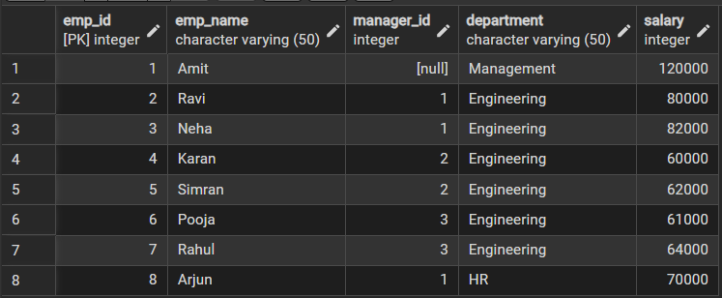

Step 1: Procedure to insert data.

Code:

CREATE OR REPLACE PROCEDURE ADD_EMPLOYEE(p_id int,p_name varchar(50),p_manager int,p_dept varchar(50),p_salary int)

AS

$$

BEGIN

INSERT INTO Employees VALUES(p_id,p_name,p_manager,p_dept,p_salary);

END;

$$ LANGUAGE PLPGSQL;

CALL ADD_EMPLOYEE(9,'Kartik',1,'HR',68000);

Output:

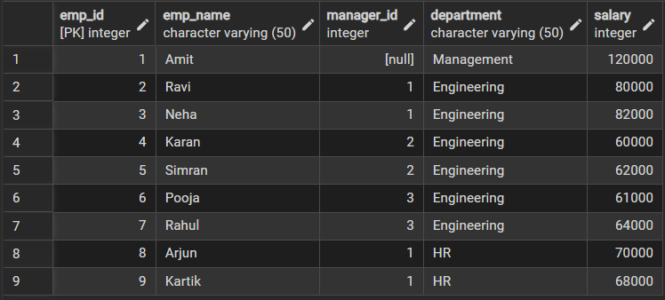

Step 2: Procedure to update data.

Code:

CREATE OR REPLACE PROCEDURE UPDATE_SALARY_PROCC(IN P_EMP_ID INT,INOUT P_SALARY NUMERIC(20,3), OUT STATUS VARCHAR(20))

AS

$$

DECLARE

CURR_SAL NUMERIC(20,3);

BEGIN

SELECT SALARY+P_SALARY INTO CURR_SAL FROM employees WHERE EMP_ID=P_EMP_ID;

IF NOT FOUND THEN

RAISE EXCEPTION 'EMPLOYEE NOT FOUND';

END IF;

UPDATE employees

SET SALARY=CURR_SAL WHERE EMP_ID=P_EMP_ID;

P_SALARY:=CURR_SAL;

STATUS:='SUCCESS';

EXCEPTION

WHEN OTHERS THEN

IF SQLERRM LIKE '%EMPLOYEE NOT FOUND%' THEN

STATUS:='EMPLOYEE NOT FOUND';

END IF;

END;

$$ LANGUAGE PLPGSQL;

-- EMPLOYEE NOT FOUND

DO

$$

DECLARE

EMP_ID INT:=99;

STATUS VARCHAR(20);

SALARY NUMERIC(20,3):=500;

BEGIN

CALL UPDATE_SALARY_PROCC(EMP_ID,SALARY,STATUS);

RAISE NOTICE 'YOUR STATUS IS %', STATUS;

END;

$$

Output:

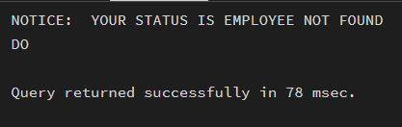

-- EMPLOYEE FOUND

DO

$$

DECLARE

EMP_ID INT:=2;

STATUS VARCHAR(20);

SALARY NUMERIC(20,3):=500;

BEGIN

CALL UPDATE_SALARY_PROCC(EMP_ID,SALARY,STATUS);

RAISE NOTICE 'YOUR STATUS IS % AND UPDATED SALARY IS %', STATUS, SALARY;

END;

$$

Output:

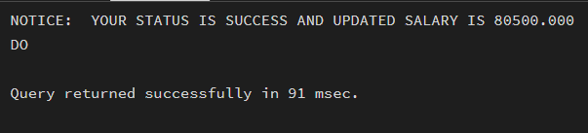

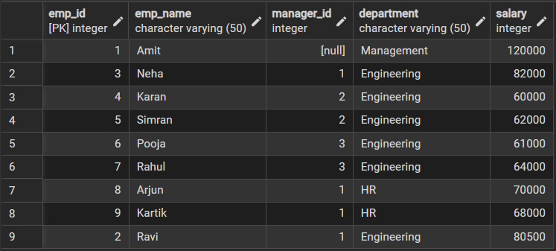

Step 3: Procedure to delete data.

Code:

CREATE OR REPLACE PROCEDURE DELETE_EMPLOYEE(p_id int)

AS

$$

BEGIN

DELETE FROM Employees WHERE emp_id=p_id;

END;

$$ LANGUAGE PLPGSQL;

CALL DELETE_EMPLOYEE(9);

Output:

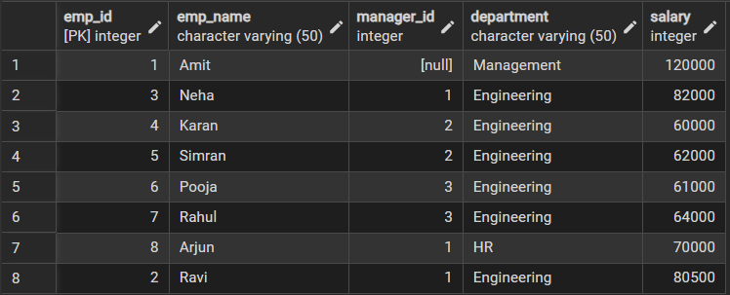

- Learning Outcomes (What I have learned):
- Learned how to create and use stored procedures
- Understood how to perform CRUD operations using procedures
- Improved understanding of database modular programming
- Learned how to enhance security and performance
- Gained hands-on experience in PostgreSQL

